Background

This report focuses on the needs and challenges of individuals who have limited cognitive capacity.  The terms Intellectual Disability, Developmental Disability, and Mental Retardation have been used to refer to this subgroup of individuals, for this report we will use the term “Individuals with Intellectual and Developmental Disabilities.” “Intellectual disability” refers to impairments in cognitive and adaptive functioning, while developmental disability is broader and includes the diagnoses of cerebral palsy, epilepsy, and autism.

California state law defines a developmental disability as “one that originates before an individual reaches 18 years of age, continues to be expected to continue indefinitely, and constitutes a substantial impairment in three or more areas of major life activity including self-care, receptive and expressive language, learning, and mobility” (The SCAN Foundation, 2013). This definition is of critical significance as it determines eligibility for Alta Regional Center Services through the Lanterman Act. Individuals with IDD meet the following criteria:

* Deficits in cognitive functioning defined as an IQ lower than 70 as measured by cognitive assessment.
* Deficits in adaptive functioning (including social skills, problem solving, and ability to carry out activities of daily living).
* Age of onset prior to 18.

Demographic information

The overall prevalence of IDD in the US is estimated at 1.5 to 2.5% (Bethesda Institute, 2012).  The California Department of Developmental Services (CDDS) provides statistics on the population of individuals with IDD for years up to 2007 (at this time, data collection methods changed and an annual report has not been published since then).  According to the CDDS, California served approximately 190,000 individuals with IDD through the public system in 2007 (CDDS, 2011).  The majority of individuals had mental retardation (75%) and a significant proportion (19%) were diagnosed with autism spectrum disorders.  In fact, the CDDS reports that the number of individuals in the system diagnosed with autism grew 321 percent (8,781 to 36,952) from 1997 to 2007.  In addition, non-Latino Whites represented the largest group served through CDDS (39%), with Latinos representing the second largest group (33%).  African Americans represented approximately 10%, Asians were 6%, Filipinos were 2%, Native Americans .4% and Pacific Islanders, .2%.   The majority of individuals with IDD lived in family homes (90%) or community supported living (8%).

Community Concerns

|  |  |
| --- | --- |
| Resettlement Difficulties | One of the most prominent themes that emerged from the interviews with key informants was the impact of resettlement difficulties on refugees and asylees.  Obtaining employment and financial security, establishing new social networks, and navigating bureaucratic systems are all significant challenges which affect the ability of refugees and asylees to resettle successfully and overcome traumatic experiences suffered prior to resettlement. |

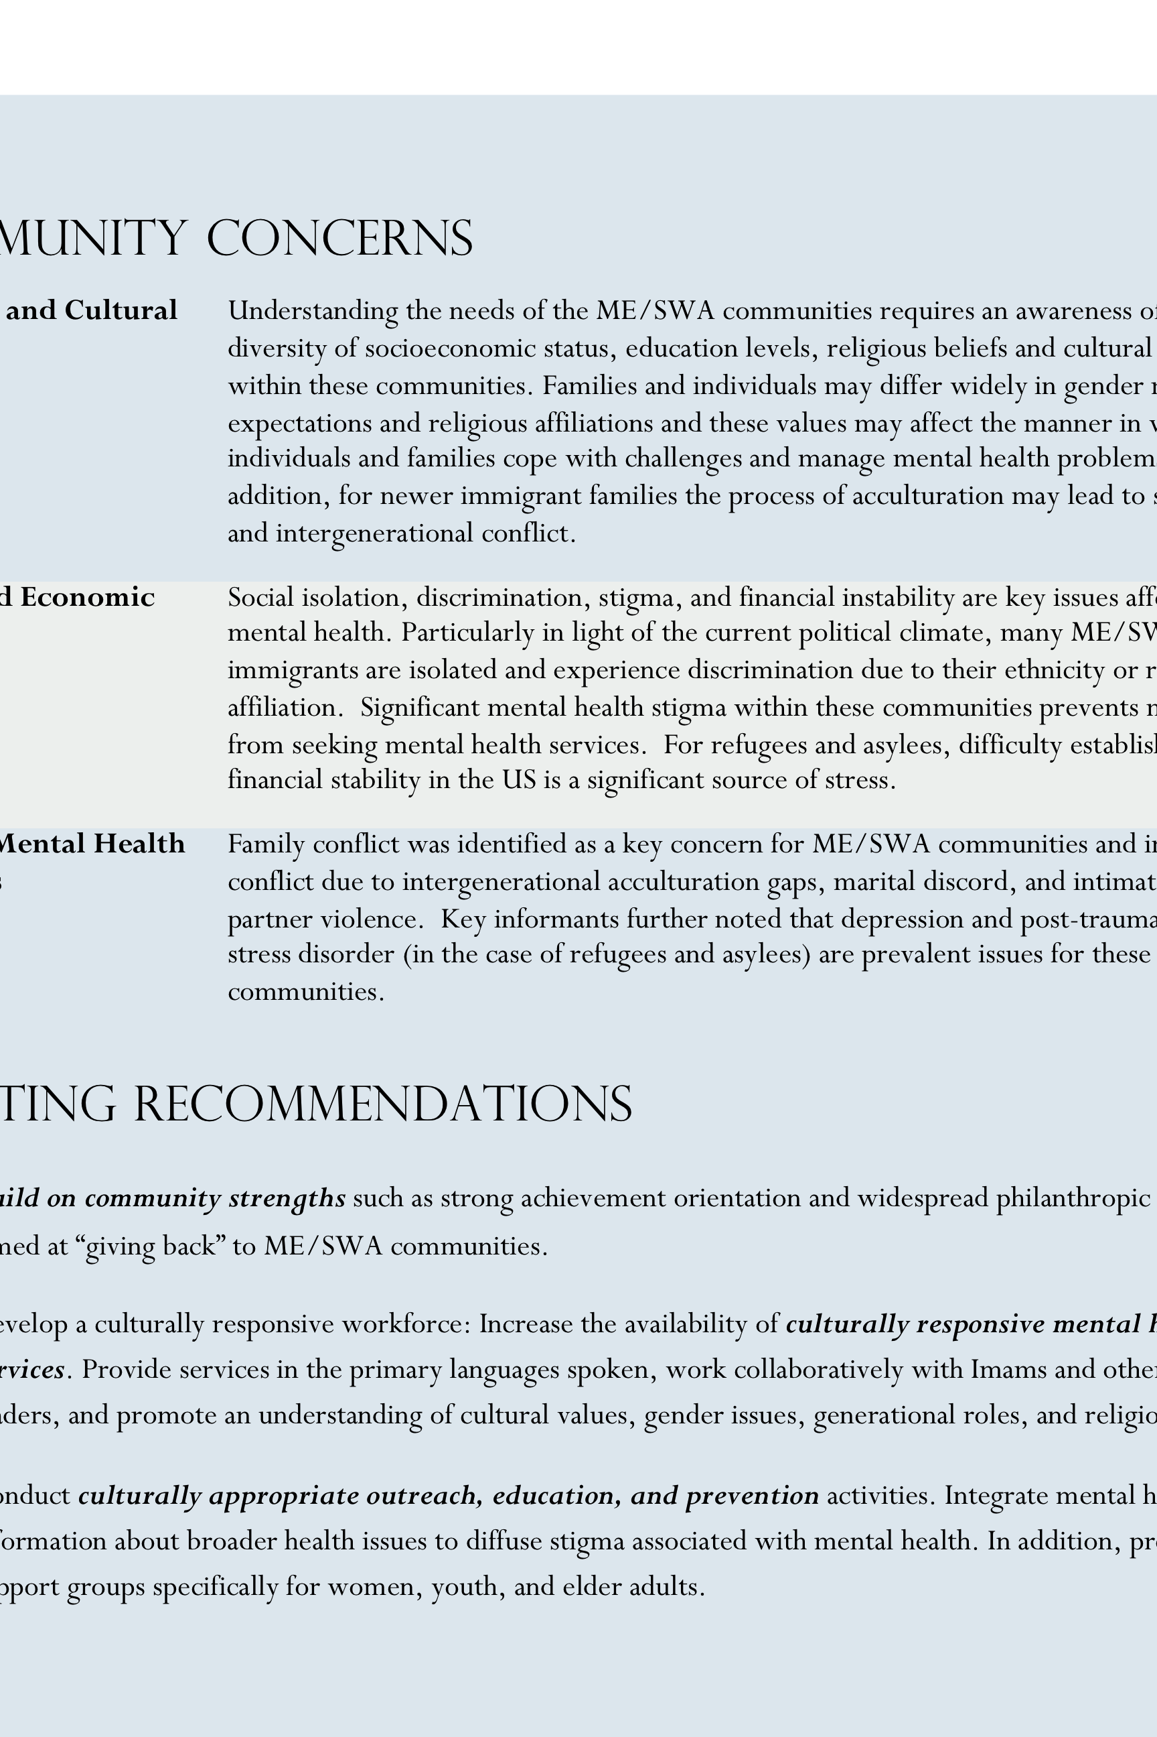ME/SWA community members have difficulty accessing services due to language, cultural barriers, and stigma. The burden falls on ethnic and faith-based community organizations to conduct outreach and education to inform community members of available services and how to access them, as well as to build trust. Community members are currently seeking services from the following resources:

* Arab Cultural and Community Center, San Francisco, CA
* Muslim American Society centers in California
* OMID Institute-Multicultural Institute for Development, Irvine CA
* Religious Leaders or Imams
* Medical Clinics and Hospitals [Note: Such resources are typically accessed as a last resort due to a lack of timely and appropriate services]

# Individuals with Intellectual and developmental disabilities In California*

In BRIEF

CMMC Presentation

2015

The California MHSA Multicultural Coalition (CMMC) is a project of the Racial and Ethnic Mental Health Disparities Coalition (REMHDCO) and is one of seven partners in the California Reducing Disparities Project (CRDP), funded by the California Department of Public Health, Office of Health Equity. For more information visit www.remhdco.org

*The information provided in this fact sheet was obtained through a qualitative study conducted by the CMMC. For more information see the *“State of the State IV: 2013-2014. Reducing Disparities in Mental Health: Refugee/Asylees and Individuals with Intellectual/Developmental Disabilities.”*



Community Concerns

|  |  |
| --- | --- |
| Financial Hardship | Attaining and maintaining financial independence and security are key concerns for individuals with IDD.  There is a dearth of supported employment programs to assist individuals with IDD.  Financial insecurity often leads to homelessness and obtaining subsidized housing for individuals with IDD is challenging. |
| Lack of Access to Care | Several factors prevent individuals with IDD from accessing health and mental health services including lack of awareness or knowledge on the part of the individual with IDD, lack of provider understanding of IDD issues and reluctance to provide care to individuals with IDD, reliance on care providers to advocate for health and mental health needs, and provider biases and cultural stigma regarding individuals with IDD. Recent budget cuts have drastically reduced the availability of social service programs available to individuals with IDD. |
| Specific Mental Health Problems | Key informants identified a prevalence of depression, anxiety, social isolation, and dementia for individuals with IDD. |
| Special Populations | Older adults and women with IDD may face specific challenges.  In particular, isolation experienced by older adults with IDD may be profound.  Women may face difficulties with health care as many providers may lack the experience or knowledge necessary to conduct a physical exam with a patient with IDD. Women with IDD are also at heightened risk for sexual exploitation and abuse, and may face greater challenges obtaining employment. |

Assets and Recommendations

* The state Regional Center Program, the statewide mandate for services for IDD instituted by the Lanterman Act, and peer run programs were viewed as critical resources for individuals with IDD.
* Participants recommended strengthening existing programs and improving coordination of services among providers, particularly county mental health departments and regional services.
* Key informants also recommended providing education and training to providers to improve capacity for providing both mental health and health care for individuals with IDD.

In BRIEF (cont.)

Maecenas malesuada elit lacinia lorem iaculis sed sodales tortor malesuada. Aenean ac ipsum elit. Sed nec neque a augue feugiat dictum ac non lectus. Phasellus vitae lectus mauris.

Nunc magna urna, molestie vitae consectetur et, lacinia quis dolor. Curabitur sollicitudin pellentesque lectus non euismod. In hac habitasse platea dictumst.

Curabitur euismod erat vel libero imperdiet sed fringilla augue scelerisque. Maecenas eget leo non nulla vehicula aliquet. Suspendisse tincidunt sem eget purus porttitor vel fermentum ligula congue. Duis quis leo nec leo tempor vestibulum nec ut eros.

Nulla non justo neque, in vulputate nisi. Cras mattis mauris sed neque egestas imperdiet. Quisque commodo varius massa in sagittis. Phasellus vel pharetra urna. Maecenas ac adipiscing justo.

Vestibulum mollis tortor ac est vestibulum eu tempor velit auctor. Duis eu nunc vestibulum nisi consequat bibendum. Phasellus bibendum orci id sapien accumsan in sodales odio tristique. In elementum nisi vitae erat congue cursus auctor quam molestie. Quisque non eleifend turpis.

Praesent tempor mauris sapien, ac viverra lectus. Nullam ornare euismod mauris, eu tempor sapien molestie sed. Fusce lacinia felis a sapien porta sed egestas ipsum congue. Suspendisse potenti. Etiam et metus nibh, nec mattis diam.