In BRIEF

CMMC Presentation

2015

Background According to US and international law, refugees and asylum seekers are defined as individuals with a well-grounded fear of persecution upon returning to their home country. The Geneva Convention suggests that “well-grounded fear” must be characterized by the following: fear of persecution based on race, religion, nationality, membership in a particular social group, or political opinion (CRS Report, 2005). Refugees and asylees are not able to return to their countries of origin due to threats to their physical safety.  In contrast to refugees, asylees typically arrive in the US prior to obtaining legal refugee status.

In addition to refugees and asylees, the California Office of Refugee Health (ORH) recognizes several other groups of individuals who may be eligible for refugee services. These include Cuban and Haitian Entrants, Victims of Human Trafficking, Amerasians (individuals who were born in Vietnam between 1962 and 1975 fathered by US citizens), and Afghani and Iraqi Special Immigrants (individuals displaced from Afghanistan and Iraq who provided services for the US during times of conflict) (California ORH, 2013).

Of note, there exists a third group of individuals who come to the US fleeing from persecution but do not seek refugee, asylee, or special status.  These individuals may continue to be fearful of the disclosing their identity, they may be reluctant to undergo the process of describing and often re-experiencing their trauma required to obtain refugee/asylee status, or they may be distrustful of the government entities.  They comprise a largely invisible group for whom services are virtually non-existent and levels of distress and suffering are high.

Demographic information The United States is one of 17 countries that currently accept refugees and asylees for permanent, rather than temporary settlement. Since 1975, 700,000 individuals with designated refugee status have arrived in California (Immigration Policy Center 2010; RFP Fact Sheet 20130). Prior to 1990, the greatest influx of refugees came from Southeast Asia: Vietnam, Cambodia, and Laos. Currently, the greatest number of refugees comes from Iran, Southeast Asia, the former Soviet Union, Iraq, and Africa. Other refugee communities residing in California include Bhutanese, Somali, Chinese, Burmese, and Afghani. Large communities of refugees have resettled in Los Angeles, Fresno, Orange County, San Diego, Sacramento, San Francisco, and Merced (ORH, 2013; estimates 2000-2009). Recent world events have also resulted in an increase in unaccompanied minors from Central and South America and will likely result in an influx of Syrian refugees.

Community Concerns

|  |  |
| --- | --- |
| Resettlement Difficulties | One of the most prominent themes that emerged from the interviews with key informants was the impact of resettlement difficulties on refugees and asylees.  Obtaining employment and financial security, establishing new social networks, and navigating bureaucratic systems are all significant challenges which affect the ability of refugees and asylees to resettle successfully and overcome traumatic experiences suffered prior to resettlement. |

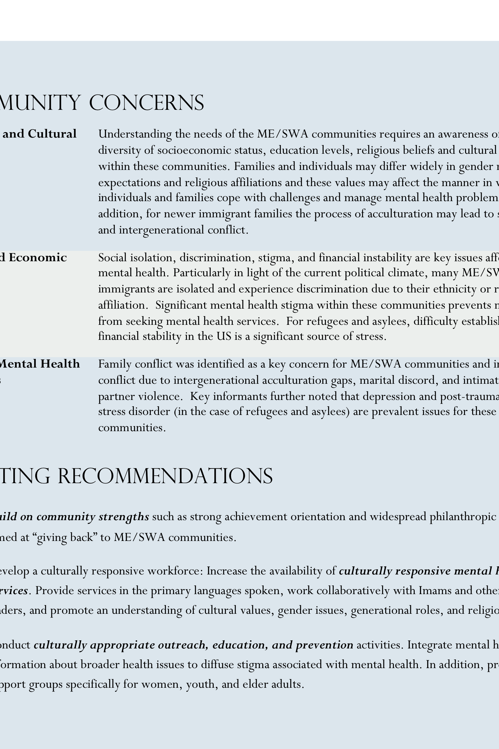ME/SWA community members have difficulty accessing services due to language, cultural barriers, and stigma. The burden falls on ethnic and faith-based community organizations to conduct outreach and education to inform community members of available services and how to access them, as well as to build trust. Community members are currently seeking services from the following resources:

* Arab Cultural and Community Center, San Francisco, CA
* Muslim American Society centers in California
* OMID Institute-Multicultural Institute for Development, Irvine CA
* Religious Leaders or Imams
* Medical Clinics and Hospitals [Note: Such resources are typically accessed as a last resort due to a lack of timely and appropriate services]

# Refugee and Asylee

# Communities In California*

Maecenas malesuada elit lacinia lorem iaculis sed sodales tortor malesuada. Aenean ac ipsum elit. Sed nec neque a augue feugiat dictum ac non lectus. Phasellus vitae lectus mauris.

Nunc magna urna, molestie vitae consectetur et, lacinia quis dolor. Curabitur sollicitudin pellentesque lectus non euismod. In hac habitasse platea dictumst.

Curabitur euismod erat vel libero imperdiet sed fringilla augue scelerisque. Maecenas eget leo non nulla vehicula aliquet. Suspendisse tincidunt sem eget purus porttitor vel fermentum ligula congue. Duis quis leo nec leo tempor vestibulum nec ut eros.

Nulla non justo neque, in vulputate nisi. Cras mattis mauris sed neque egestas imperdiet. Quisque commodo varius massa in sagittis. Phasellus vel pharetra urna. Maecenas ac adipiscing justo.

Vestibulum mollis tortor ac est vestibulum eu tempor velit auctor. Duis eu nunc vestibulum nisi consequat bibendum. Phasellus bibendum orci id sapien accumsan in sodales odio tristique. In elementum nisi vitae erat congue cursus auctor quam molestie. Quisque non eleifend turpis.

Praesent tempor mauris sapien, ac viverra lectus. Nullam ornare euismod mauris, eu tempor sapien molestie sed. Fusce lacinia felis a sapien porta sed egestas ipsum congue. Suspendisse potenti. Etiam et metus nibh, nec mattis diam.

The California MHSA Multicultural Coalition (CMMC) is a project of the Racial and Ethnic Mental Health Disparities Coalition (REMHDCO) and is one of seven partners in the California Reducing Disparities Project (CRDP), funded by the California Department of Public Health, Office of Health Equity. For more information visit www.remhdco.org

*The information provided in this fact sheet was obtained through a qualitative study conducted by the CMMC. For more information see the *“State of the State IV: 2013-2014. Reducing Disparities in Mental Health: Refugee/Asylees and Individuals with Intellectual/Developmental Disabilities.”*



Community Concerns

|  |  |
| --- | --- |
| Cultural and Historical Factors | Experiences prior to resettlement may include extreme deprivation and exposure to intense violence and combat. Some refugee and asylee communities may have histories of political conflict within or between ethnic groups.  Still other communities may have widely differing views of health, mental health, and treatments.  These factors affect the health, mental health, and wellbeing of refugees and asylees and affect their willingness to reach out to community members or social service providers for help. |
| Specific Mental Health Concerns | For refugee and asylee communities the chief mental health concern is Post-Traumatic Stress Disorder.  In addition, challenges of resettlement as well as losses related to the flight from their home country may contribute to the development of depression, anxiety, substance abuse, and intimate partner violence. |
| Special Populations | Resettlement may be particularly difficult for women, who often have responsibility for maintaining family functioning both financially and emotionally.  In addition, older adults may experience isolation in resettlement due to loss of community and language barriers. |

Assets and Recommendations

* The resilience and strength of refugees and asylees in the face of extraordinary trauma and loss is a key asset for these communities.
* Participants recommended utilizing existing community resources such as community leaders and faith based organizations to provide prevention services to refugee and asylee communities.
* Services should focus on improving awareness of mental illness and treatments as well as providing health promotion programs for victims of trauma to prevent the onset of mental illness.
* Improving access to services in the refugee or asylee’s primary language was recommended.  Key informants suggested that existing resettlement programs should be strengthened as they are understaffed and overburdened.

In BRIEF (cont.)

Maecenas malesuada elit lacinia lorem iaculis sed sodales tortor malesuada. Aenean ac ipsum elit. Sed nec neque a augue feugiat dictum ac non lectus. Phasellus vitae lectus mauris.

Nunc magna urna, molestie vitae consectetur et, lacinia quis dolor. Curabitur sollicitudin pellentesque lectus non euismod. In hac habitasse platea dictumst.

Curabitur euismod erat vel libero imperdiet sed fringilla augue scelerisque. Maecenas eget leo non nulla vehicula aliquet. Suspendisse tincidunt sem eget purus porttitor vel fermentum ligula congue. Duis quis leo nec leo tempor vestibulum nec ut eros.

Nulla non justo neque, in vulputate nisi. Cras mattis mauris sed neque egestas imperdiet. Quisque commodo varius massa in sagittis. Phasellus vel pharetra urna. Maecenas ac adipiscing justo.

Vestibulum mollis tortor ac est vestibulum eu tempor velit auctor. Duis eu nunc vestibulum nisi consequat bibendum. Phasellus bibendum orci id sapien accumsan in sodales odio tristique. In elementum nisi vitae erat congue cursus auctor quam molestie. Quisque non eleifend turpis.

Praesent tempor mauris sapien, ac viverra lectus. Nullam ornare euismod mauris, eu tempor sapien molestie sed. Fusce lacinia felis a sapien porta sed egestas ipsum congue. Suspendisse potenti. Etiam et metus nibh, nec mattis diam.